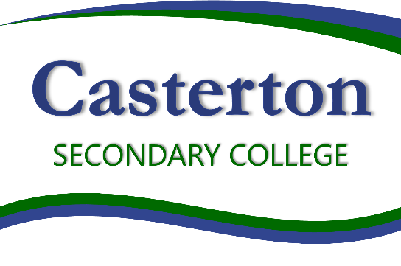

Casterton Secondary College is committed to ensuring that a Child Safe environment is provided for all students
Casterton Secondary College is compliant with the
Child Safe Standards.
Casterton Secondary College is committed to diversity through a safe and inclusive environment for our school community

POLICY Review and approval
Policy last reviewed | Term 2, 2022
Consultation | Endorsed by School Council 08/08/2022
Approved by | Principal
Next scheduled review date | 2024

